CONFIDENTIAL
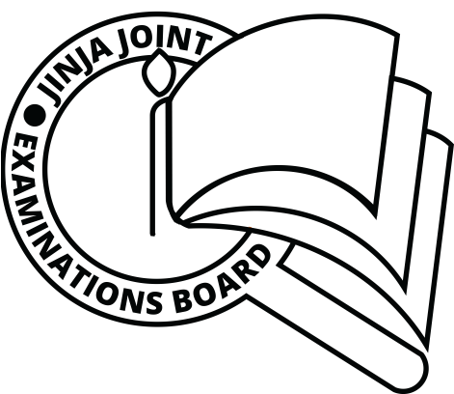
545/3/Inst. Sc.
CHEMISTRY
PRACTICAL
INSTRUCTIONS
Paper 3
AUGUST, 2019

JINJA JOINT EXAMINATIONS BOARD

Uganda Certificate of Education

MOCK EXAMINATIONS –AUGUST, 2019

CHEMISTRY

PRACTICAL

INSTRUCTIONS

Paper 3

CONFIDENTIAL:

GREAT CARE SHOULD BE TAKEN THAT THE INFORMATION GIVEN BELOW
DOES NOT REACH THE CANDIDATES EITHER DIRECTLY OR INDIRECTLY.

- The description of the reagents and chemicals specified below does not necessarily correspond with the description in the question paper. Candidates must NOT be informed of the difference.

- Candidates are not allowed to use reference books (i.e. textbooks, booklets on qualitative analysis etc) during the examination.

- In addition to the ordinarily fittings and apparatus contained in a Chemistry laboratory, each candidates will require:

Requirements:
- 1 Pipette (25cm³/20cm³)
- I burette (50cm³)
- 2 conical flasks
- 80cm³ of BA1
- 6 test tubes
- 1 boiling tube
- 1 filter paper
- 90cm³ of BA2, which is 0.1M hydrochloric acid
- 2g of Z
- BA1 is prepared by dissolving 3.8g of X in water to make 1 dm of water.
- Substance X and Z will be provided by JJEB.

